Opgave 1: Debugging i IntelliJ

Bug # 1 Battleship is always in Horizontal position

Using a breakpoint in battleshipGame.setupBoard();
I inspected the value returned by: return new Random().nextInt(maxValue );
The debugger showed that the value was always 0, meaning the vertical branch (case 1) was never executed. I fixed the issue by changing the argument to :
return new Random ().nextInt(maxValue + 1); , allowing both horizontal and vertical ship placement.

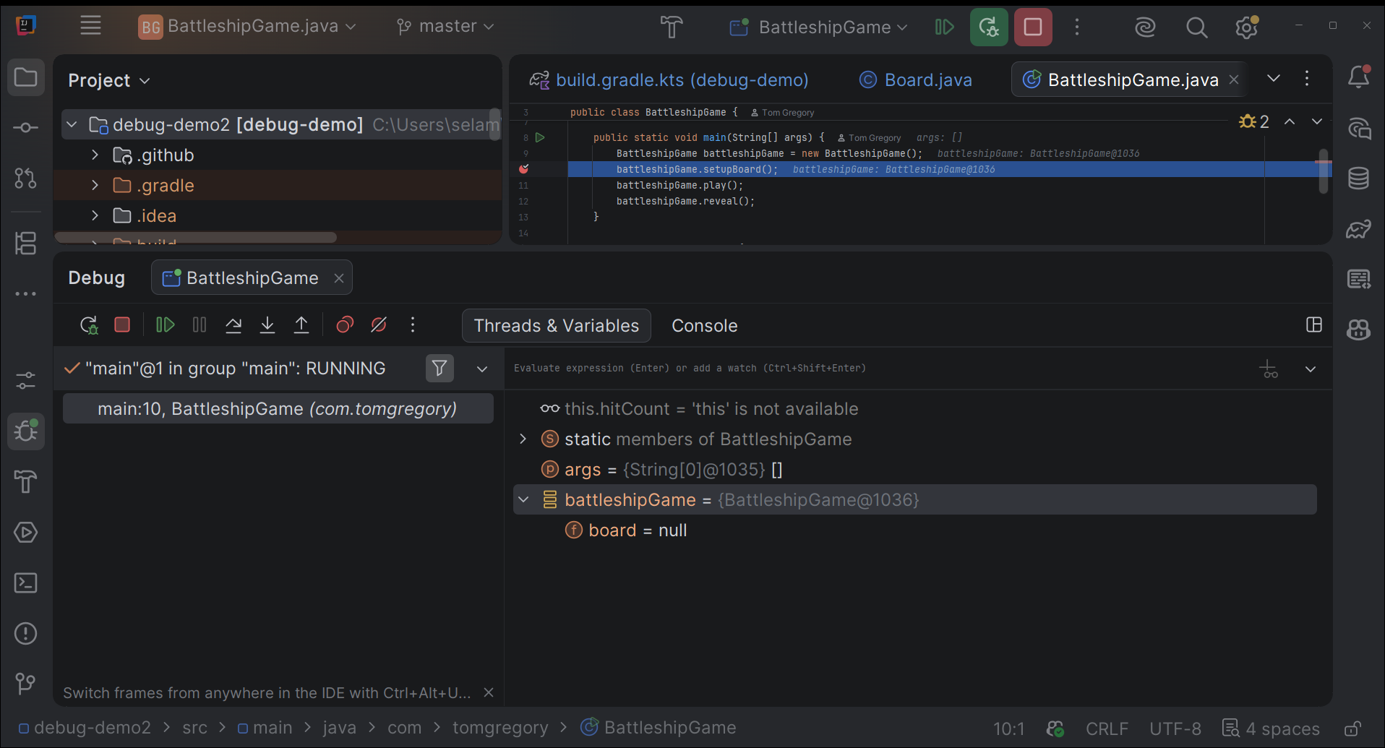

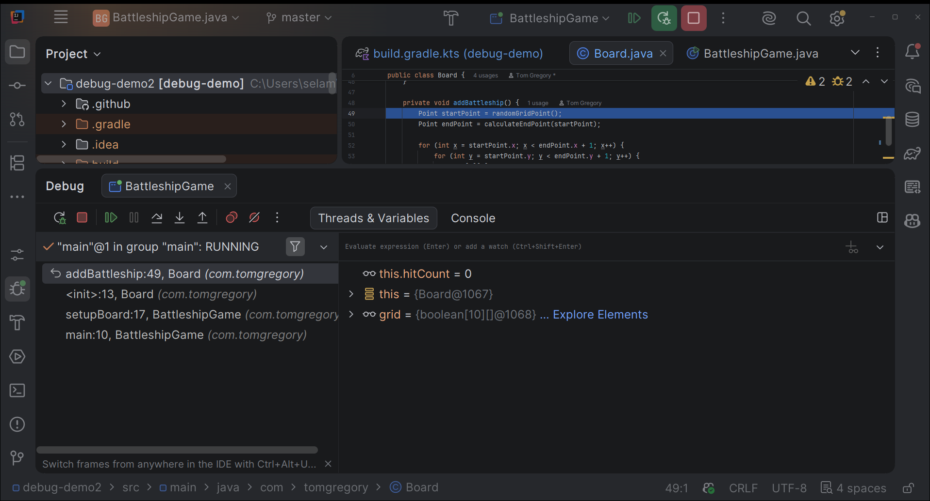
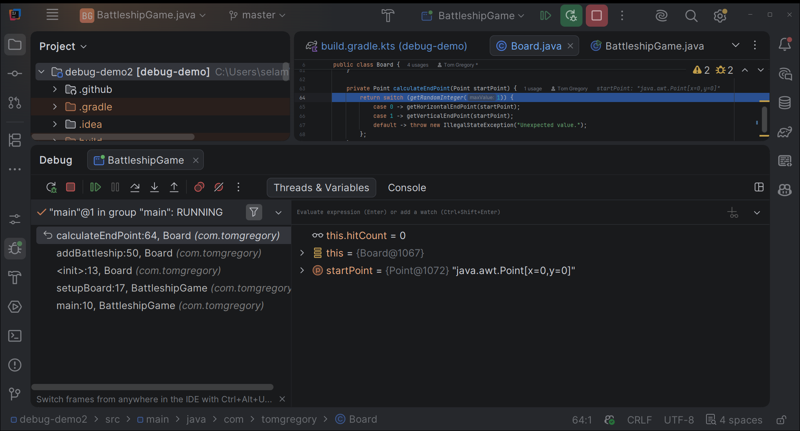

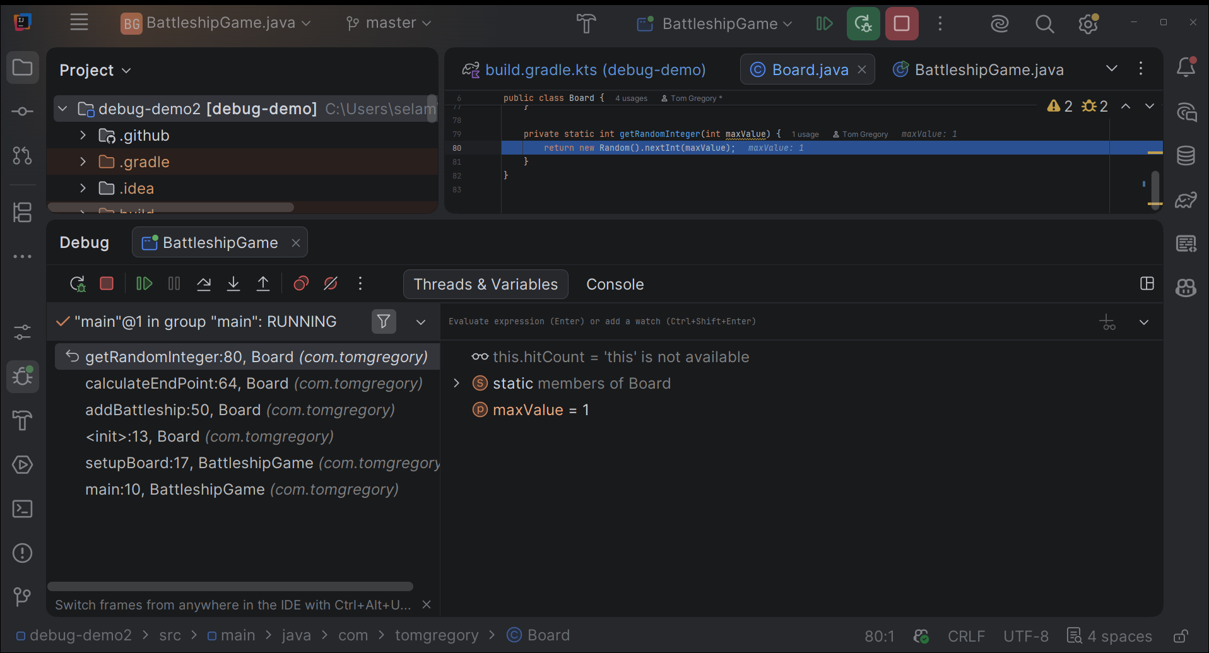
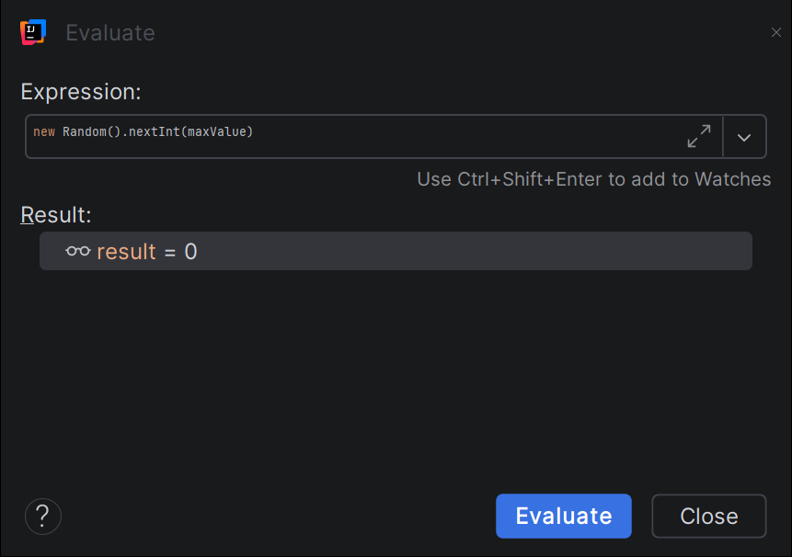

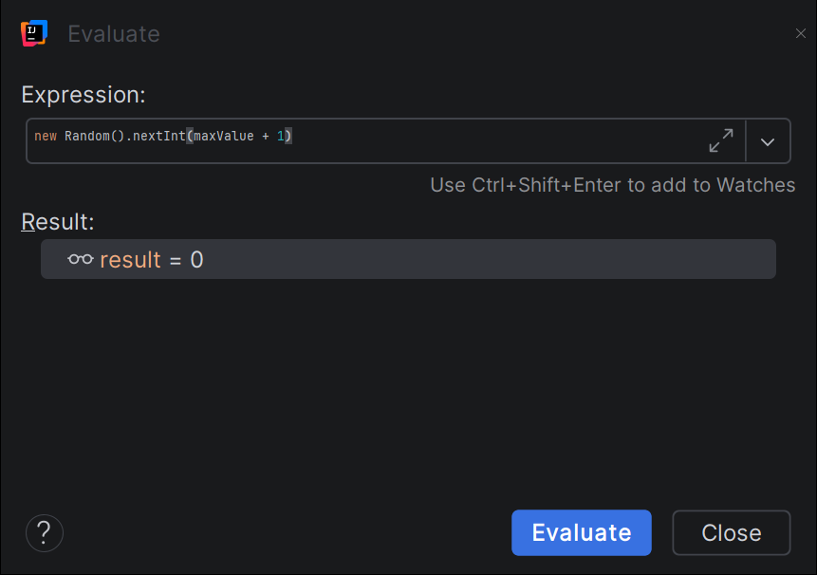

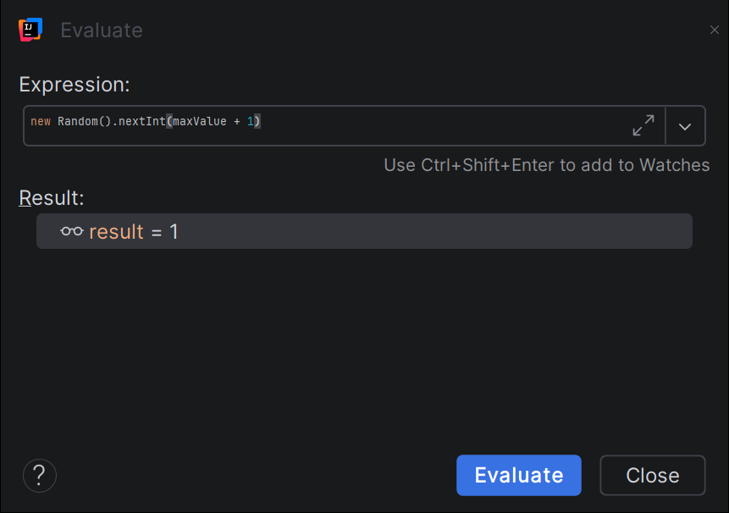
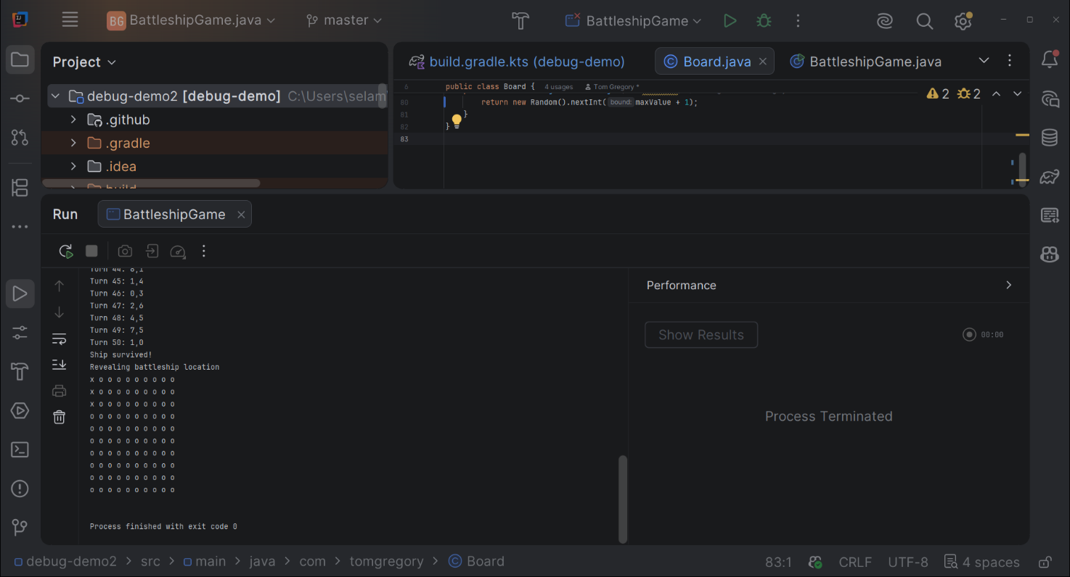

I have got the vertical positioning, and this is the end of the first bug.
Bug # 2 After I had three direct hits on the ship (on Turn 8,29,40) the ship survived and the game continued after a win this is my second Bug.
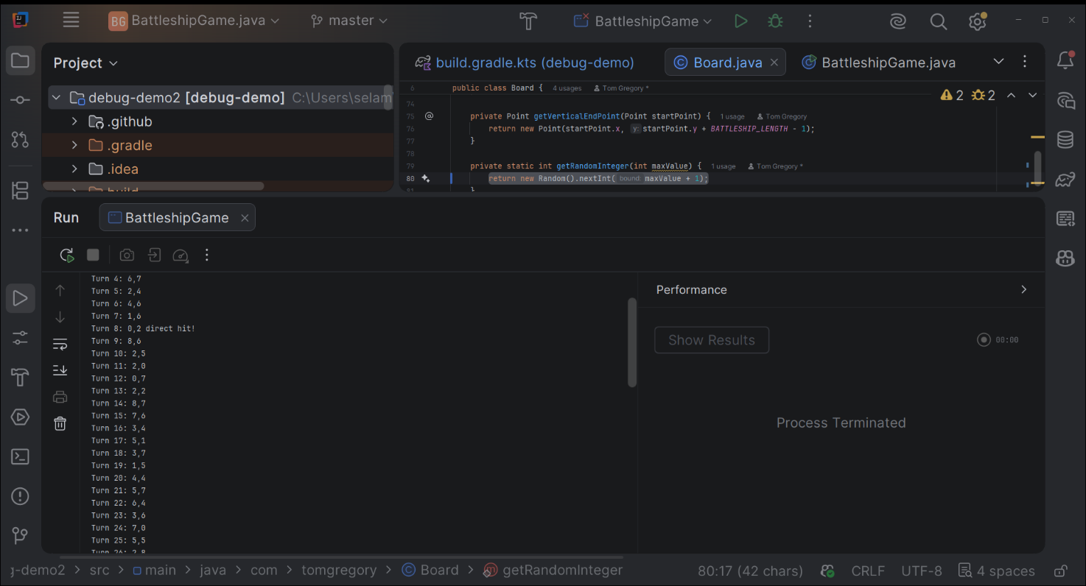

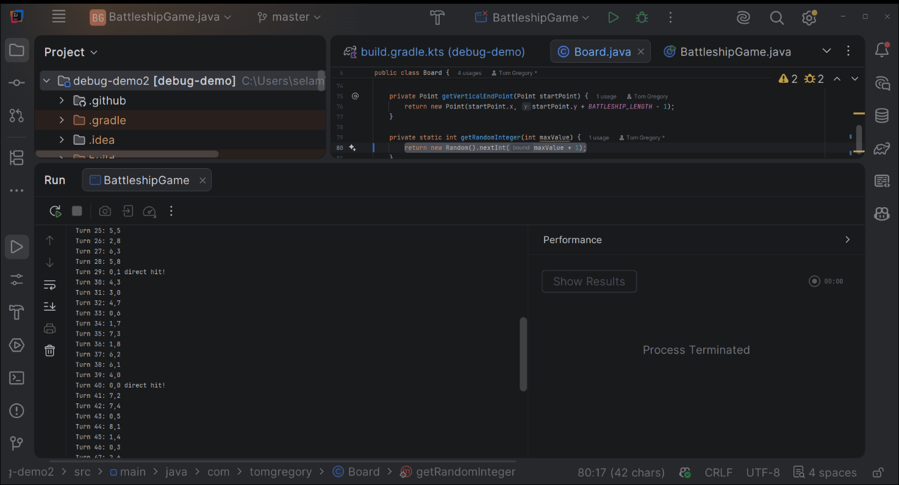

I start by making break point on play method: battleshipGame.play();

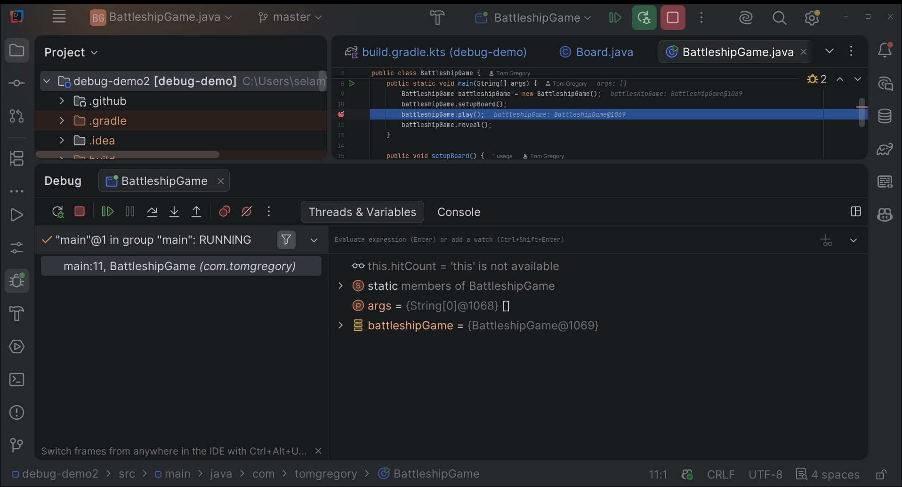
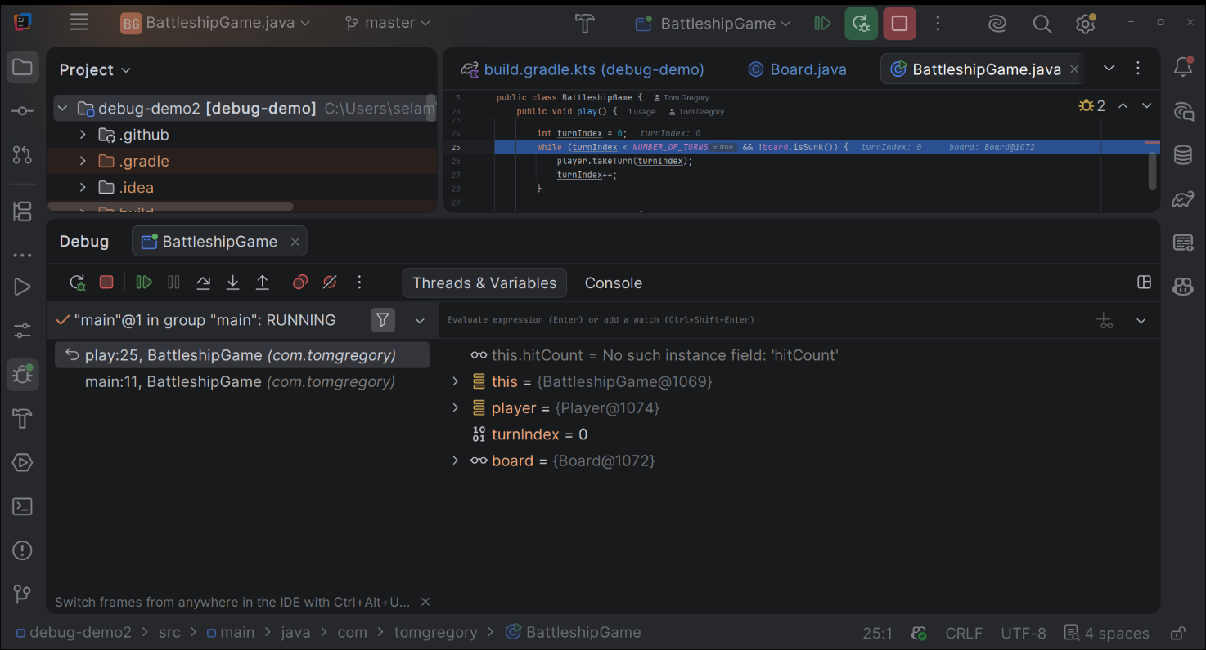
Made also special breakpoint:
Conditional BreakPoints – I want to check if the
public boolean isSunk() {
return hitCount > BATTLESHIP_LENGTH; return true, when the hit count is 3.
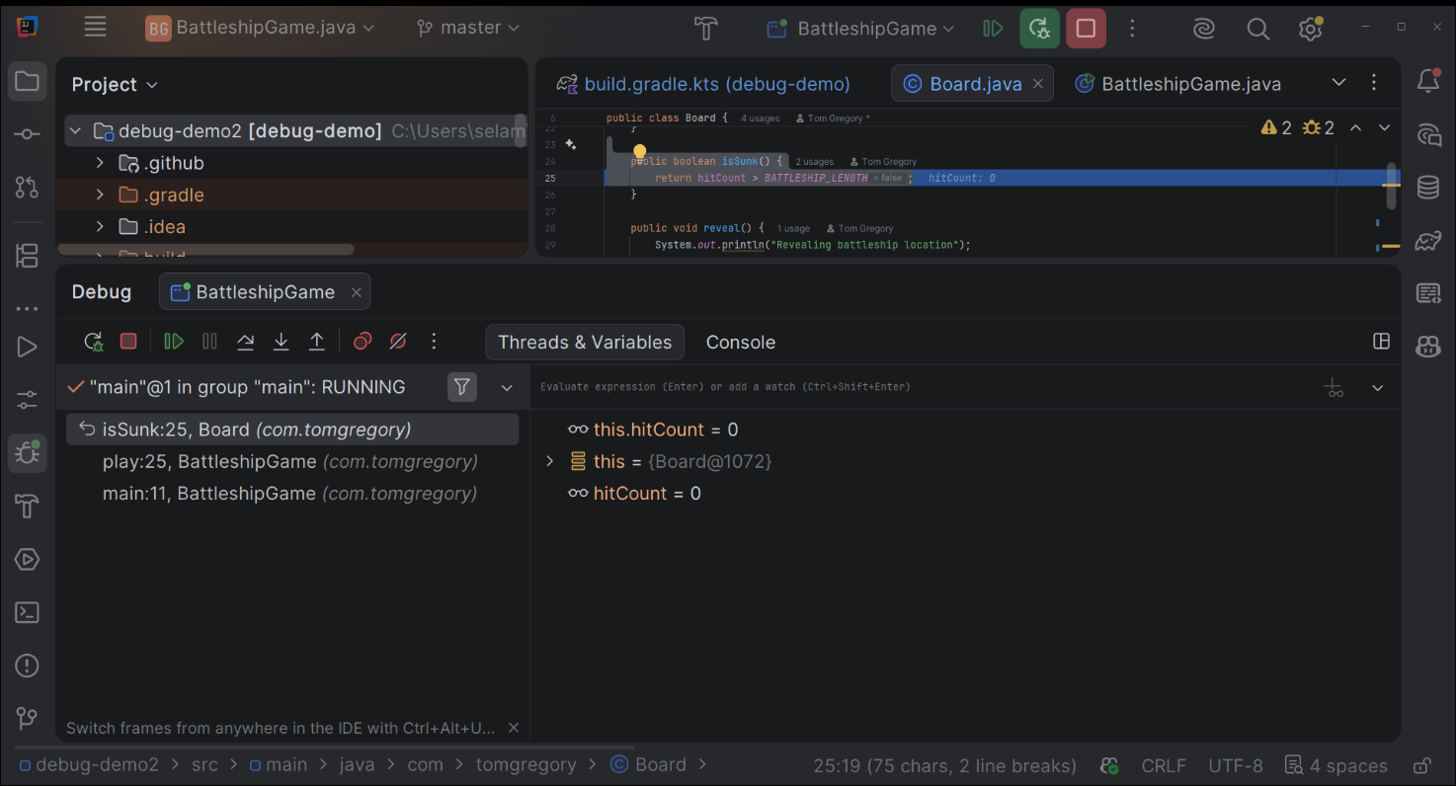

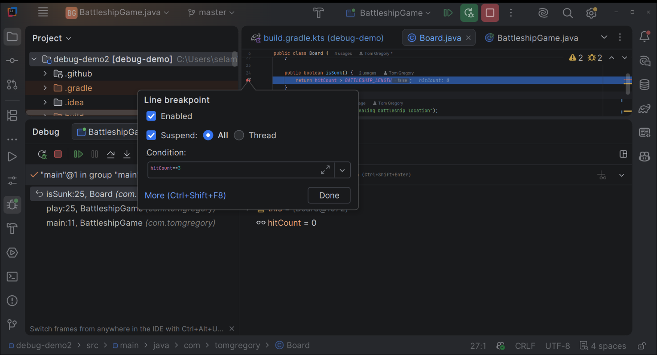

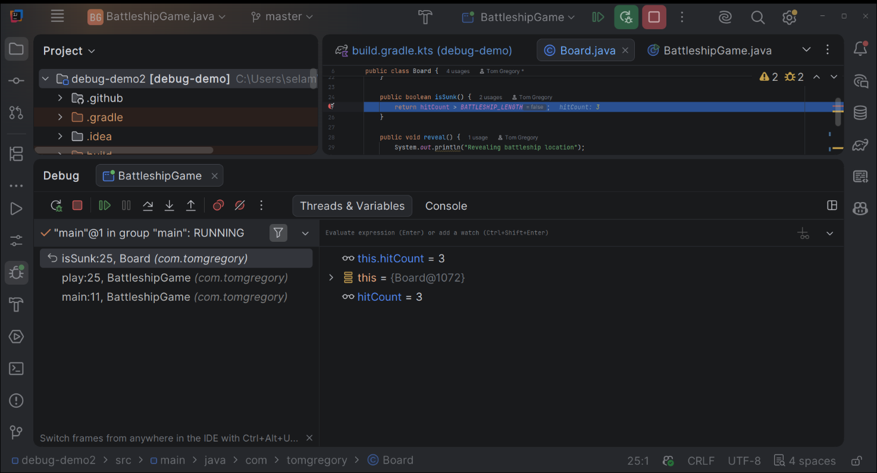

Made change with > = in the code line below:
return hitCount >= BATTLESHIP_LENGTH;
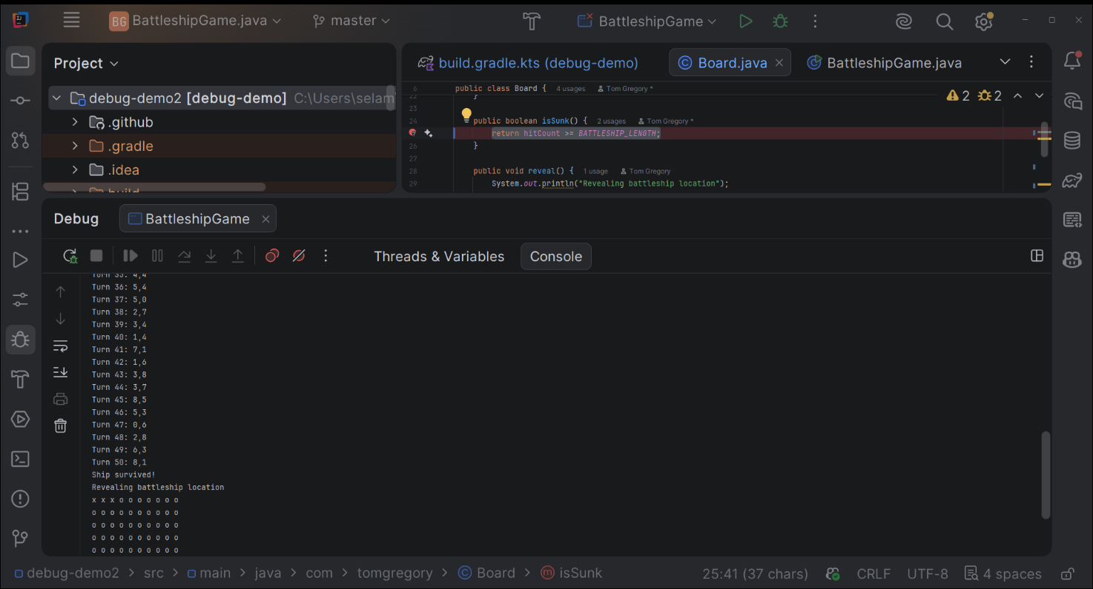

Running the game after the changes, I have got three direct hit turns in (Turn 16,21,43) and the ship also sunk.

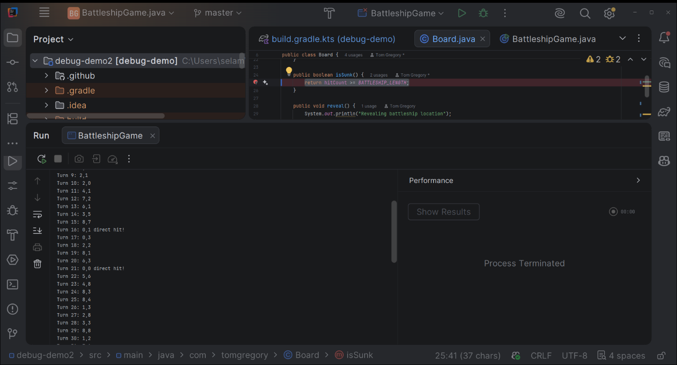

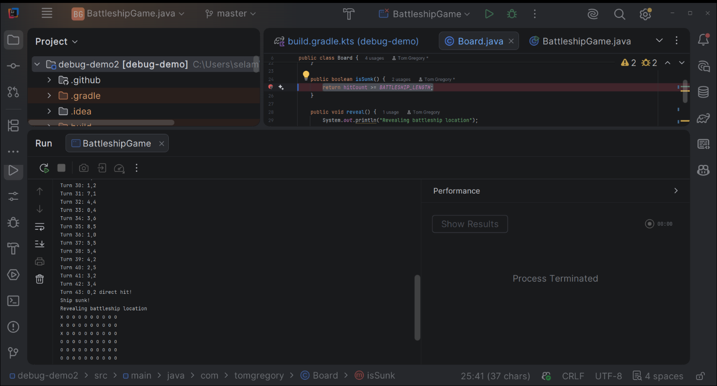

Bug #3 Array index out of bound problem another exception break point

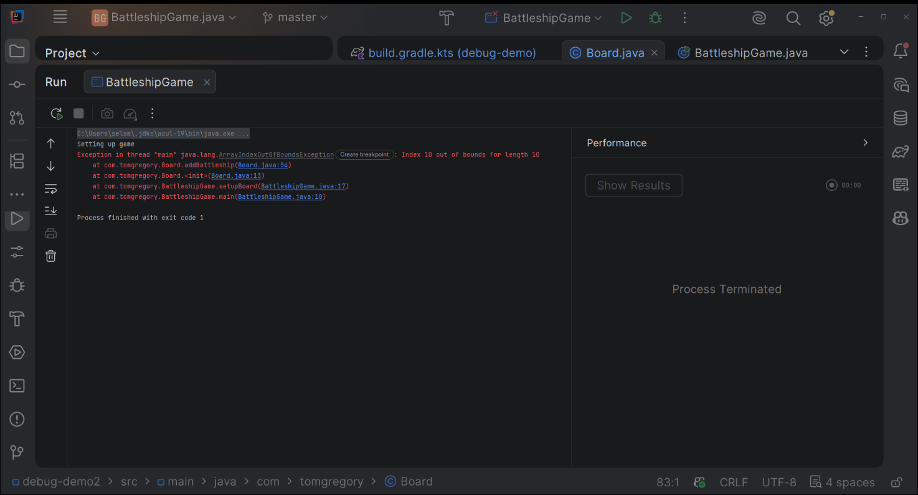
Created a break point exception
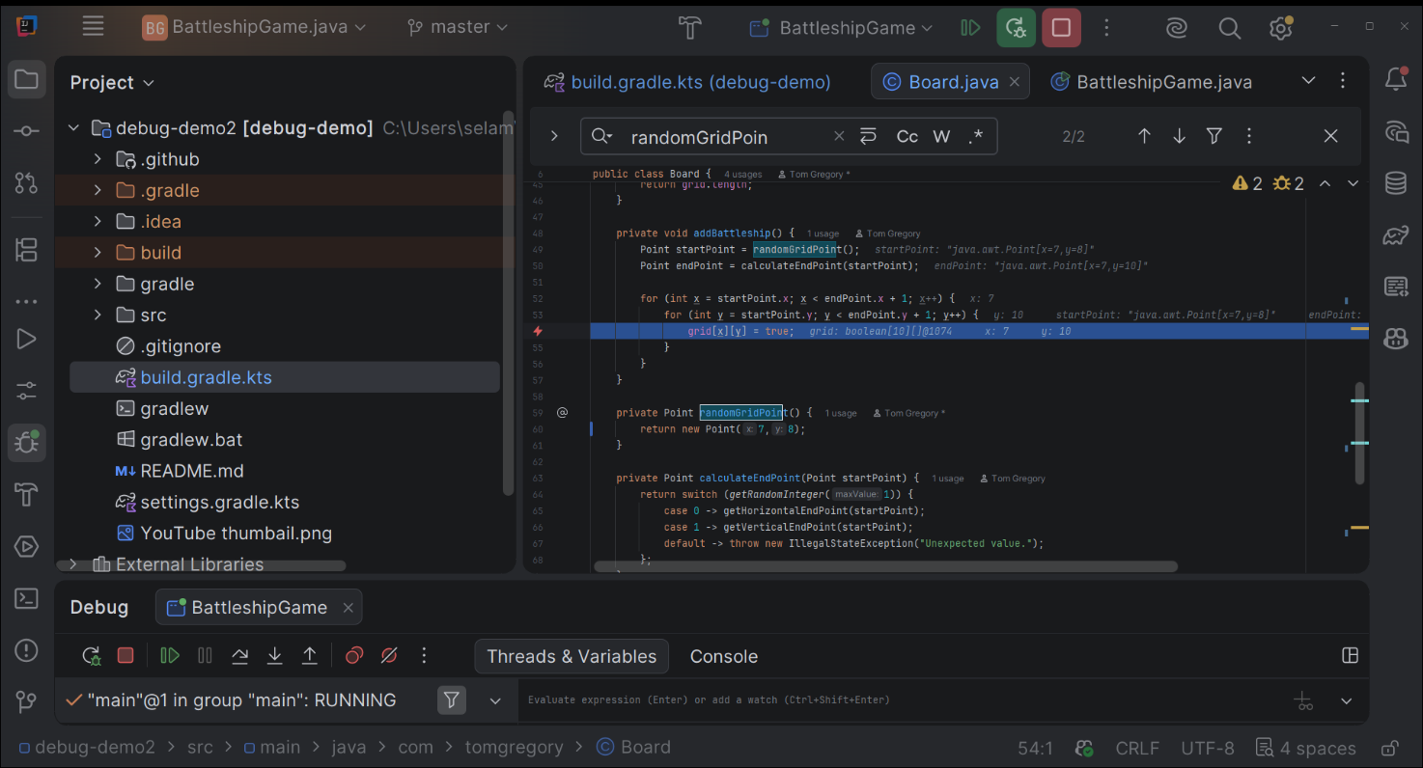

Debug until I get the exception thrown and explore what causes the problem:
There is a grid of array 10*10 and it goes from 0 -9 indexes from the picture below I can see the value of y is 10,( y=10) it is out of bound because the maximum index is 9

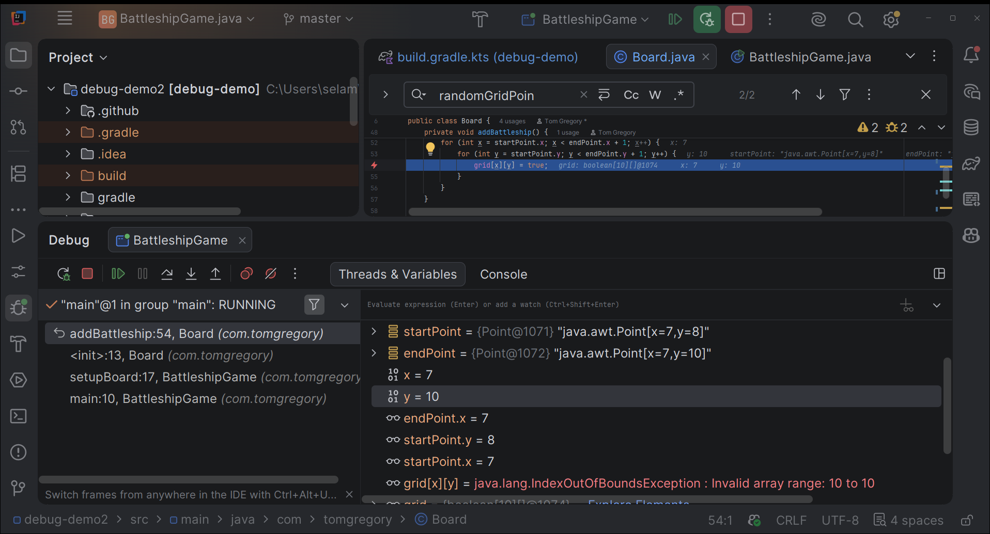

The problem is that this code is not intelligent enough at this point to check when the ship goes outside the boundary of 10*10 grid. I need to add some extra code to do the check.
And that is the” do while loop” which is going to calculate the start and end points.I have got also the “ isWithinGrid” method to check the end point is with in the boundary.

Point startPoint;
Point endPoint;
do {
startPoint = randomGridPoint();
endPoint= calculateEndPoint(startPoint);
} while (!isWithinGrid(endPoint));
for (int x = startPoint.x; x < endPoint.x + 1; x++) {
for (int y = startPoint.y; y < endPoint.y + 1; y++) {
grid[x][y] = true;
}
}
}
private Point randomGridPoint() {
return new Point(getRandomInteger(grid.length - 1), getRandomInteger(grid.length - 1));
}
private boolean isWithinGrid(Point point) {
return point.x >= 0 && point.x < grid.length && point.y >= 0 && point.y < grid.length;
}
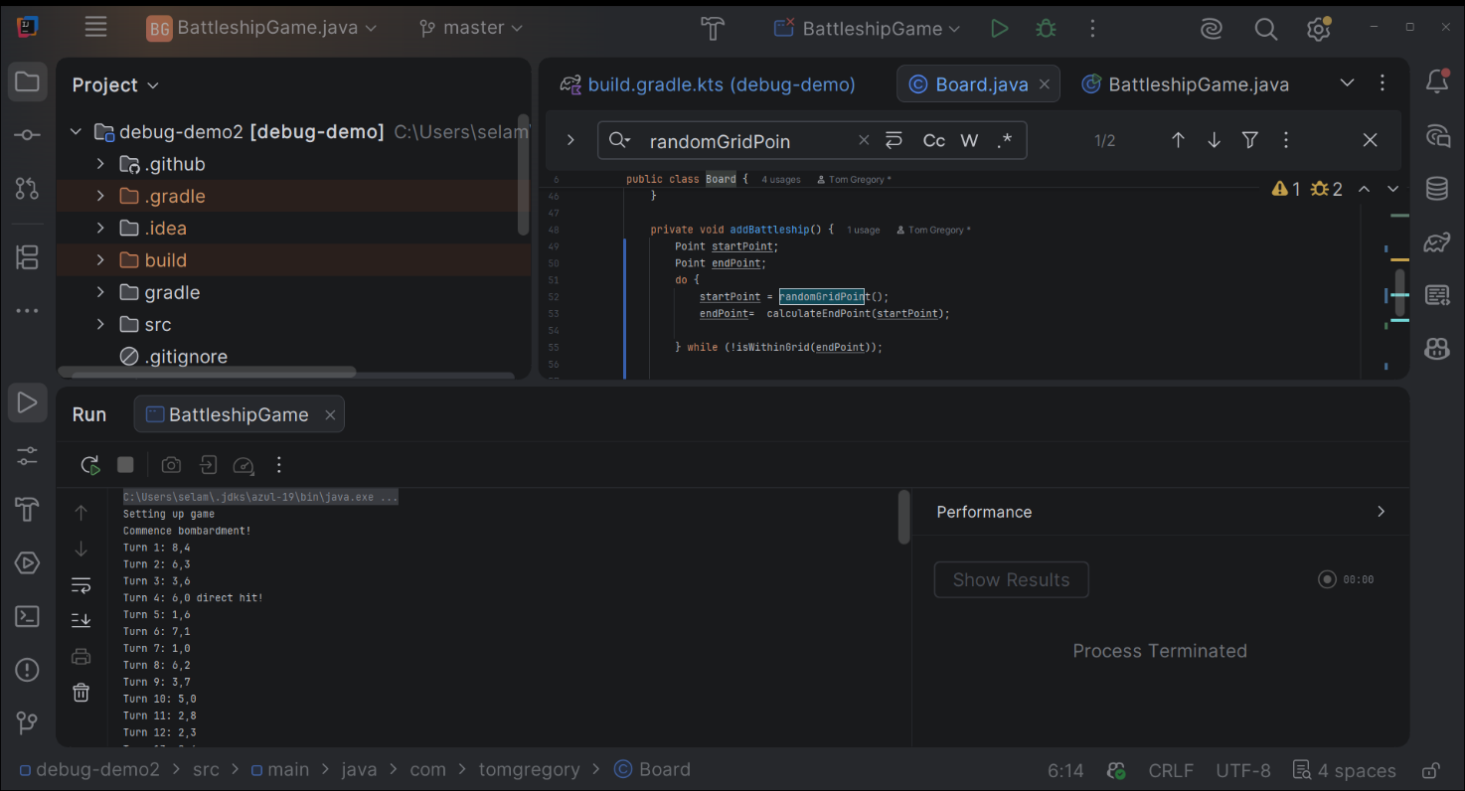

Finally, I got the third bug fixed and I am able to run the program as much as I wanted.

